|  |
| --- |
| BODY - CHARTS |

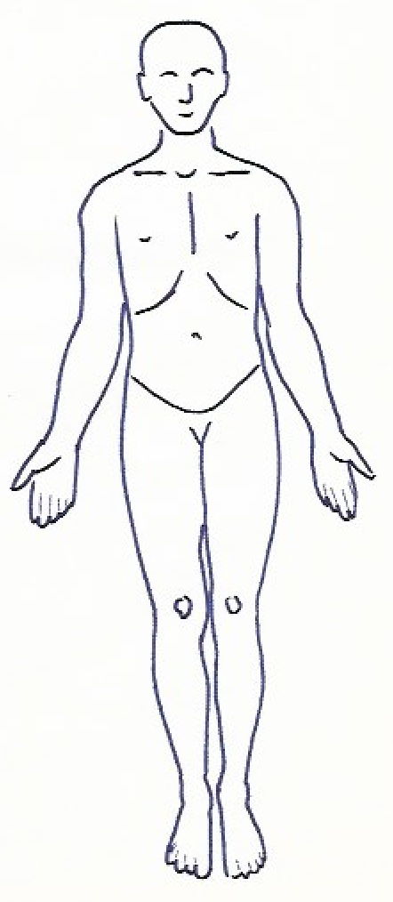   

BODY – CHART BGM / MTCo / MTC

|  |
| --- |
|  |

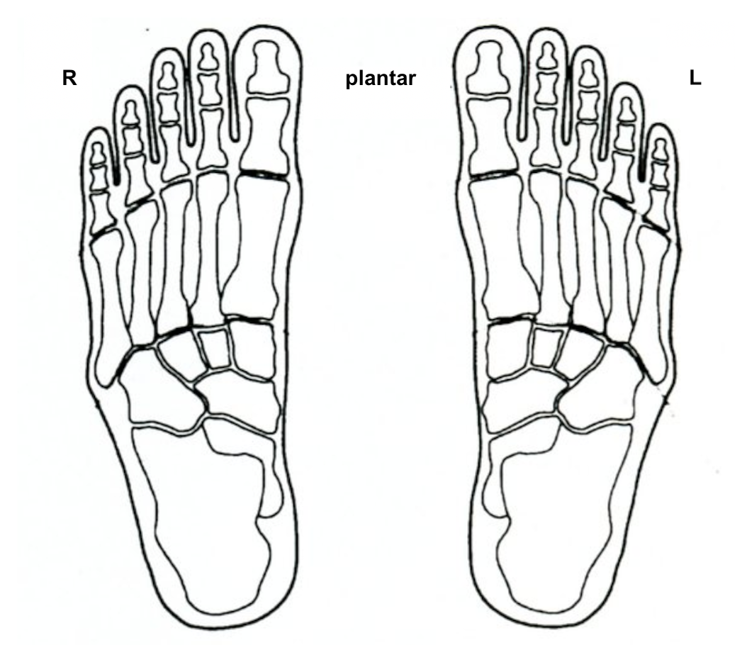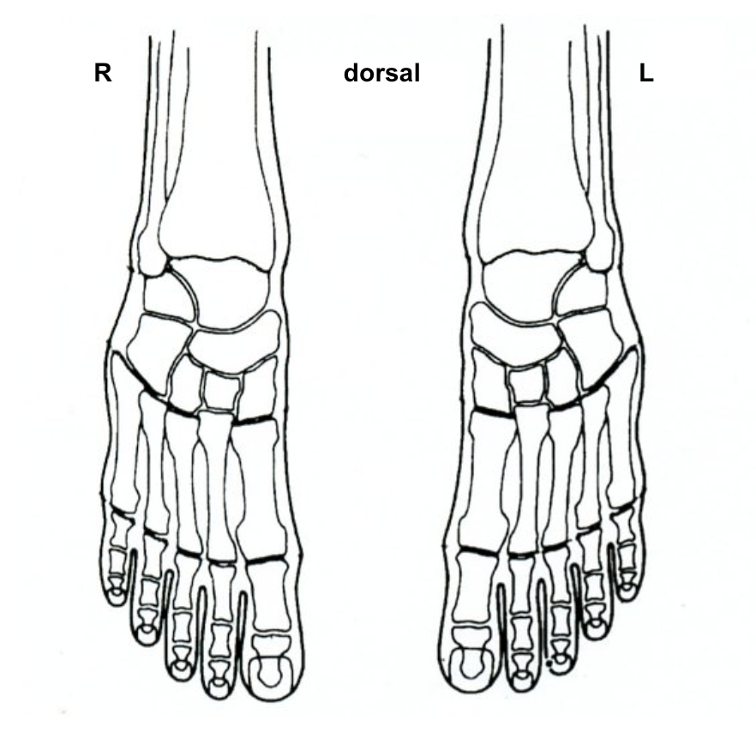FRZ / RP / MZRP (Schema nach/selon/secondo H. Marquardt)

